

**NATIONAL CERTIFICATE**

# STRENGTH OF MATERIALS AND STRUCTURES N5

(8060065)

**28 July 2021 (X-paper)**

**09:00–12:00**

**REQUIREMENTS: Hot-rolled structural steel tables BOE8/2**

## Drawing instruments and nonprogrammable calculators may be used

**This question paper consists of 5 pages and a formula sheet of 2 pages.**

076Q1G2128

**DEPARTMENT OF HIGHER EDUCATION AND TRAINING**

**REPUBLIC OF SOUTH AFRICA**

NATIONAL CERTIFICATE

STRENGTH OF MATERIALS AND STRUCTURES N5

TIME: 3 HOURS

MARKS: 100

## INSTRUCTIONS AND INFORMATION

1. Read all the questions carefully.

1. Answer all the questions.

1. Number the answers according to the numbering system used in this question paper.

1. Start each question on a new page.

1. Show all the calculation steps where calculations should be done.

1. Sketches must be large, neat and fully labelled.

1. Write neatly and legibly.

## QUESTION 1

After a failure seen on a steering system tie rod, the manufacturers decided to perform a tensile test on a rod specimen to better understand its material capabilities. The diameter of the specimen is 21,5 mm and the gauge length is 90 mm.



The followings results were generated by the test:

* Load at the limit of proportionality = 113 kN
* Extension at the limit of proportionality = 0,00121 mm
* Load at the yield point = 258 kN
* Ultimate tensile strength load = 449 kN



* Load at the fracture = 162 kN
* Total extension after fracture = 9,264 mm
* Diameter after fracture = 14,88 mm

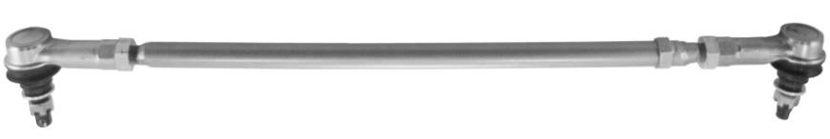

[Source: [*https://www.walshrc.com/product/tie-rod-kits/*]](https://www.walshrc.com/product/tie-rod-kits/)

## FIGURE 1

Calculate the following:

1.1 The stress at the limit of proportionality (3)

1.2 Young’s modulus of elasticity for the material (3)

1.3 The yield stress (3)



1.4 The maximum stress (3)

1.5 The breaking stress (3)

1.6 The percentage elongation (3)

1.7 The percentage reduction in area (3)

1.8 Draw a force-extension curve using an approximate scale. (6)



1.9 The strain energy of a same-sized specimen when a load is gradually applied (3)

## [30] QUESTION 2

2.1 List FIVE possible causes of unequal settlement in foundations. (6)



2.2 A thin cylindrical pipe with a diameter of 200 mm and a thickness of 4 mm is fitted with end plates. It is subjected to an internal pressure of 4,8 MPa.

2.2.1 Calculate the longitudinal stress induced. (5)

2.2.2 What axially applied compressive load will decrease the

longitudinal stress to zero? (3)



**[14]**

## QUESTION 3

FIGURE 2 shows a propped cantilever. Draw the shear force and the bending moment diagram if the reaction in the prop is 33,2 kN. In addition, calculate the position of the inflection point for the bending moment diagram.

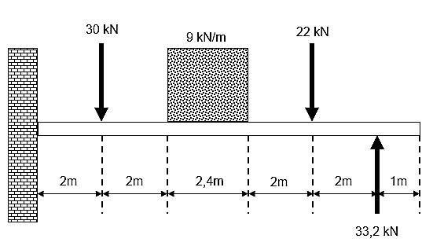

## FIGURE 2 [17]



## QUESTION 4

The connecting rod in FIGURE 3 is used for a two-stroke petrol engine. The length of the connecting rod is 43,5 mm. The top bushing diameter is 4,9 mm and the bottom bushing diameter is 6 mm.



The dimensions of the rectangular rod member are 8 mm and 4,5 mm in both axes.

|  |  |  |
| --- | --- | --- |
|  | | |
|  |  |  |
|  |  |  |
|  |  |  |
|  |

E = 88 GPa.

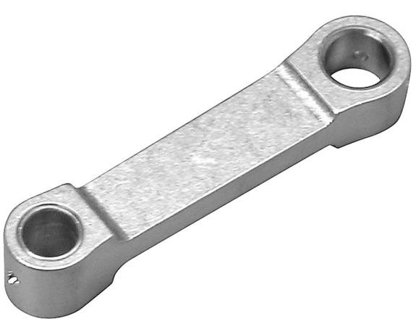

[Source: *https://www.towerhobbies.com/cgi-bin/wti0001p?&I=L×CF43*]

## FIGURE 3

Analyse the connecting rod and use Euler’s equation to determine the buckling load for

the connecting load. **[13]**



## QUESTION 5

A solid shaft with a diameter of 215 mm rotates at 400 r/min and the maximum shear stress in the shaft is 27 GPa.

Calculate the following:



5.1 The power transmitted by the solid shaft (7)

5.2 The internal diameter if the solid shaft is replaced by a hollow shaft with an outside diameter of 220 mm (the power transmitted remains the same as that of the solid shaft and the maximum shear stress increases to 32 GPa by

material hardening) (7)

**[14]**

## QUESTION 6

6.1 Name SIX possible tests that can be carried out to determine the different

strengths of a material. (6)



|  |  |  |  |
| --- | --- | --- | --- |
| 6.2 | List THREE advantages of an indentation system. |  | (6)  **[12]** |
|  |  | **TOTAL:** | **100** |

(8060065) -1-

## STRENGTH OF MATERIALS AND STRUCTURES N5

Any applicable equation or formula may be used.

*F WL* = *M* =

*A* 8

*X*

= *L* *M* =8*L*2

*FL WL E* = *Ax* *M* = 4

 1 1  *I*

*F* *A*1*E* + *A*2*E* =*t*(2 −1) *Z* = *y*



*F* *AL*11*E* + *AL*22*E* = *L*11*t* + *L*22*t* *MI* ==*Z*(*D* 4 − *d*4)

64 1

*U* = 2 *Fx* *I* =  4  *D*

64 *F*2*L*

*U* = 2*AE* *Ixx* = *bd*3

*ac*

*b*

*b*

4

2

−



−

12

*x*= 2*a*  *F* =2*EI*2

*F*2*L Le*

*mg*(*h* +) =

2*AE F* = *A* 2

*T* == *G* 1 + *a**Le* 

*J r L*  *k* 

(*D*4 − *d*4) 42*EI*

*J* = 32 *F* = 2

*L*

2

4

1













+

*k*

*L*

*a*

*A*

⬧

*A*

*I*

*F* =

(*D*4 − *d*4)

❐

*T* = 

16 *D*

*k* =

*T* = 16*D*3 *S* .*v* = *Lke* ; *S* . *R* = *Lke* 10,2 *TL* Hinged ends *Le* = *L*

= 4

# *GD L*

Fixed ends *Le* =

10,2 *TL* 2

= *G*(*D*4 − *d*4) One end fixed, one end hinged *Le* = *L*

2

Copyright reserved Please turn over (8060065) -2-

*P* = 2*NT*

*M*  *E* = = *I Y R*

One end fixed, one end free *Le* =2*L*

*PD*

=

2 . *t*

*PD*

=

4 *t*

(*p* − *d*) *t**t* 100

=

*pt**t*

*d*2 *n*

=100 *pt**t ndt**c* 100

4

=

*pt**t* *d*2

*t*(*p* − *d*) *t* =  *nt*

4

(*p* − *d*) *t**t* = *dtn**c*

Copyright reserved